**North Dakota Corn Potassium Calculator**

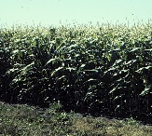

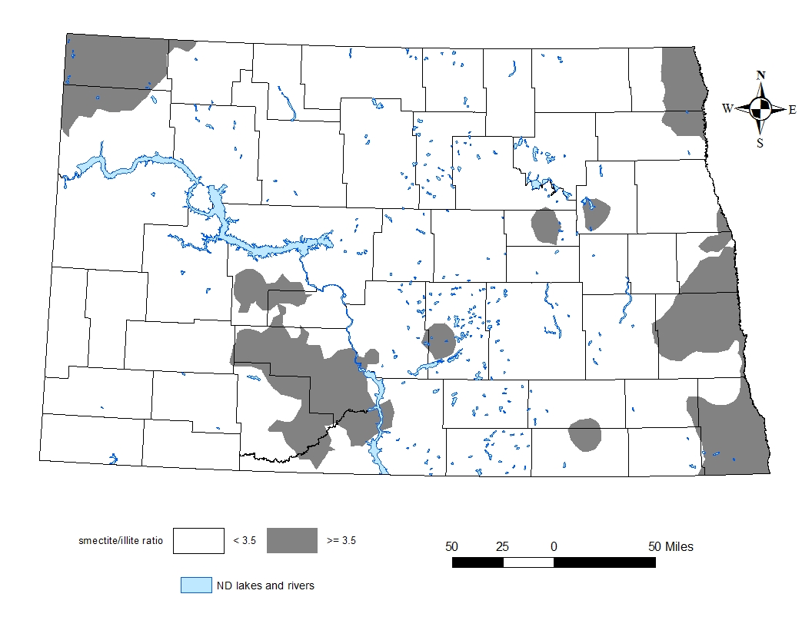

**Help Determine the Precise Potassium Needs for Your Corn**

